
SECJ2203: Software Engineering

System Documentation (SD)

Project Title

Version X

Date

Faculty of Computing

Prepared by: <Team name>

Revision Page
- Overview
Describe the content of the current version of SD (see below – the note in red).

- Target Audience
State the targeted audience for the SD.

- Project Team Members
List the team members in a table by stating their roles and the status for each assigned task e.g. by sections for this SD version (complete, partially complete, incomplete). If the assigned tasks are not done and have been assigned to other team members, state accordingly.
Member Name | Role | Task | Status

- Version Control History
Version | Primary Author(s) | Description of Version | Date Completed
1.0 | Team leader 1 (Full Name) | Completed Chapter X, Section… | dd/mm/yyyy
…

Note: The title page should show the latest version. For your first submission (PR2-Chap.1 and 2), it should be 1.0, then 2.0 for PR3 and 3.0 for PR4. Primary author(s) could be the team leaders who should compile all materials for the purpose of SD submission. [remove this note in red texts and the examples in the table above]

Note:
This System Documentation (SD) template is adapted from IEEE Recommended Practice for Software Requirements Specification (SRS) (IEEE Std. 830-1998), Software Design Descriptions (SDD) (IEEE Std. 1016­1998 1), and Software Test Documentation (IEEE Std. 829-2008) that are simplified and customized to meet the need of SECJ2203 course at School of Computing, UTM. Examples of models are from Arlow and Neustadt (2002) and other sources stated accordingly.

Table of Contents
1 | Introduction |  | 1
 | 1.1 | Purpose | 1
 | 1.2 | Scope | ?
 | 1.3 | Definitions, Acronyms and Abbreviations | ?
 | 1.4 | References | ?
 | 1.5 | Overview | ?
2 | Specific Requirements |  | ?
 | 2.1 | Persona | ?
2.1.1 Persona 1 (User type 1/Actor 1)
2.1.2 Persona 2 (User type 2/Actor 2)
2.1.3 Persona 3 (User type 3/Actor 3)
2.1.n Persona n (User type n/Actor n)
 | 2.2 | System Features  2.2.1 Use Case Diagram  2.2.2 Domain Model: Class Diagram  2.2.3 State Diagram
 | 2.3 | Launch Phase
 | 2.4 | User Story Details
2.4.1 US001: User Story <User Story 1>
User Story description of US001
Activity Diagram of US001
System Sequence Diagram of US001
2.4.2 US002: User Story <User Story 2>
User Story description of US002
Activity Diagram of US002
System Sequence Diagram of US002
2.4.3 US002: User Story <User Story 3>
User Story description of US003
Activity Diagram of US003
System Sequence Diagram of US003
2.4.n USxxn: User Story <User Story n>
User Story description of US00n
Activity Diagram of US00n
System Sequence Diagram of US00n
 | 2.5 | Performance and Other Requirements (Non Functional)
 | 2.6 | Design Constraints

Introduction
The following sections of the System Documentation (SD) should provide the details of the entire document comprises SRS, SDD, STD. Remove the notes in red texts when submitting including these notes.

  - Purpose
This subsection should:
- Delineate the purpose of the SD;
- Specify the intended audience for the SD.
This SD describes…

  - Scope
This subsection should:
- Identify the software product(s) to be produced by name (e.g., Host DBMS, Report Generator, etc.);
- Explain what the software product(s) will, and, if necessary, will not do;
- Describe the application of the software being specified, including relevant benefits, objectives, and goals;
- Be consistent with similar statements in higher-level specifications (e.g., the system requirements specification), if they exist.
The software product is…

  - Definitions, Acronyms and Abbreviation
This subsection should provide the definitions of all terms, acronyms, and abbreviations used in the SD.
Definitions of all terms, acronyms and abbreviations used are to be defined here.

  - References
This subsection should:
- Provide a complete list of all documents referenced elsewhere in the SD;
- Identify each document by title, report number (if applicable), date, and publishing organization;
- Specify the sources from which the references can be obtained.
Specify a complete list of references using a standardized reference format.

  - Overview
This subsection should:
- Describe what the rest of the SD contains;
- Explain how the SD is organized.
Give an overview of the content of this SD document.

Specific Requirements
This section of SD serves as the SRS that should contain all the software requirements to a level of detail sufficient to enable designers to design a system to satisfy those requirements, and testers to test that the system satisfies those requirements. Throughout this section, every stated requirement should be externally perceivable by users, operators, or other external systems. These requirements should include at a minimum a description of every input (stimulus) into the system, every output (response) from the system, and all functions performed by the system in response to an input or in support of an output.

  - Persona
Describes the intended users of the system and their characteristics, such as their technical expertise, knowledge, and physical abilities. This section is important because it provides the development team with a clear understanding of whom the system is designed for, and helps to ensure that the system is developed to meet the needs of its intended users.

2.1.1 Persona 1: KADA’s Employee
User Need
KADA’s employee need a way to become a member of the KADA to be eligible to apply loan from the organization.
User Stories
- As a KADA’s employee, I want to apply for a personal loan through the KADA for my personal financial.
- As a KADA’s employee, I have to register as a membership of KADA with my own KADA’s official email.
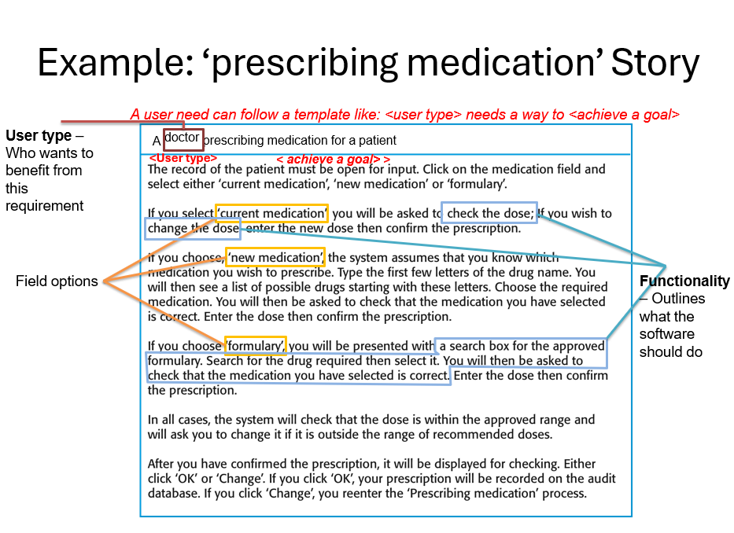
2.1.2 Persona 2 (User type 2/Actor 2)
User Need
User Stories

2.1.3 Persona n (User type n/Actor n)
User Need
User Stories

  - System Features
Specify the product perspective.
Example.
The Emotion Chatbot Analyzer is a software system that operates on mobile devices, including both Android and iOS operating systems. The system provides a means for UTM students to better manage their emotional health and at the same time simplifies the process of seeking emotional support from UTM counselors The system also implemented a real-time cloud-based database for better user experiences.

Specify the product module and function..
Include use case diagram here – see an example of Emotion Chatbot Analyzer below
Then, provide the description of each module and function using a table.

Example.
The system features is illustrated in Figure X.X below. The detail description of each module and functions is tabulated in Table X.X.

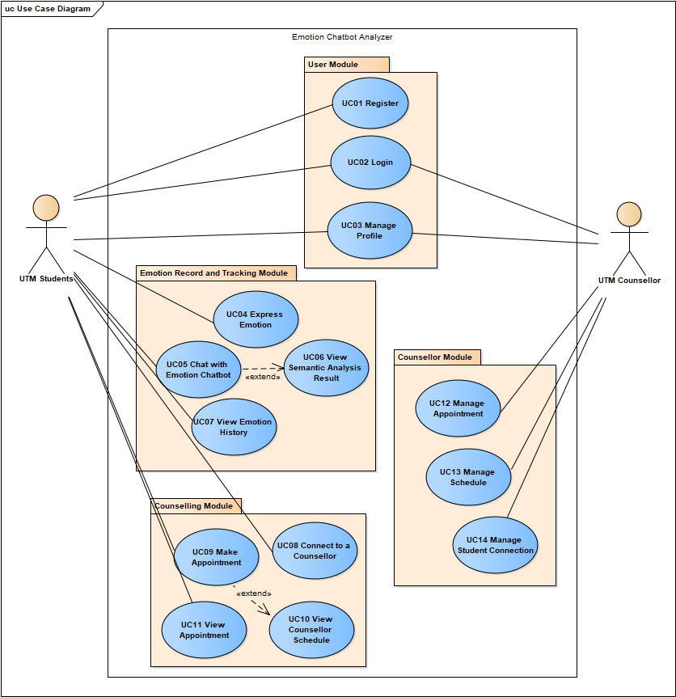
Figure X.X: Use Case Diagram for <Name of the System>

Table X.X: Description of Module and Functions for <Name of the System>
Use case | Function | Description
UC001 | Register | This use case allows students to sign up as a user for the mobile application.

[Include domain model i.e. class diagram without the operation part – only attributes without details on visibility and type, explain each class and its attributes including the relationships among the classes, see the example.]
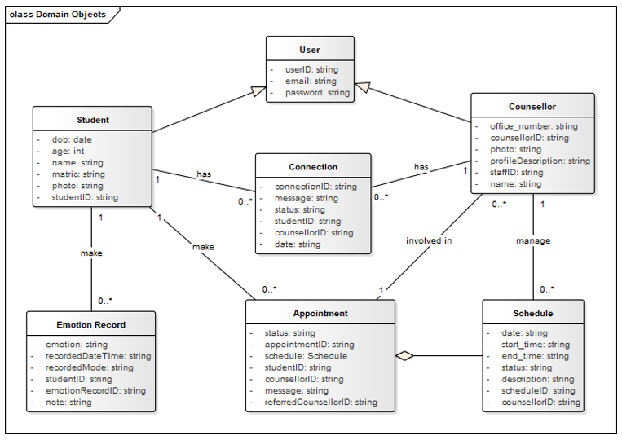
Figure X.X: Domain Model for <Name of the System>
[Include domain model i.e. class diagram without the operation part – only attributes without details on visibility and type, explain each class and its attributes including the relationships among the classes, see the example. For the class with the states only, consider including its state machine diagram, see the example for state machine diagram of Account class]

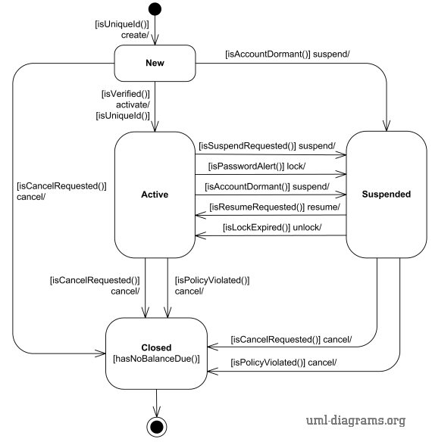
Figure X.X: State Machine Diagram for <Name of the System>

As this is often the largest and most important part of the SRS, the following principles apply:
- Specific requirements should be stated in conformance with all the characteristics described in 4.3. (IEEE Std 830-1998)
- Specific requirements should be cross-referenced to earlier documents that relate.
- All requirements should be uniquely identifiable. [Provide ID to each functional requirement]
- Careful attention should be given to organizing the requirements to maximize readability.
[For each functional requirement, indicate its details using use case description. Include sequence diagram for each use case i.e. functional requirement. Combine alternate flows in the same sequence diagram. Split only if they are too cluttered to be combined.]

  - Launch Phase
Product Backlog [describe more on product backlog];
Sprint | Team members assigned
Sprint #1
Which user story assigned to this Sprint
[you can also specify based on which module you want to develop for each sprint – based on your use case diagram]
Sprint #2
Which user story assigned to this Sprint
Sprint #n
Which user story assigned to this Sprint

  - User Story Details
[Provide ID for each user story such as US001 and so on…
Include User Story Description for each use case as in the example below. If there are any alternative flows, add the rows accordingly. Otherwise, just remove the rows. Ensure each User Story has its own unique ID and the name of the heading corresponds to the name of use case in the use case diagram (refer to Figure 2.1). Different scenarios of a user story require separate descriptions.]

2.4.1 US001: User Story <User Story 1>

Table 2.1: User Story Description for <Name of Use Case>
User story: <Name of Use Case>
ID: USxxx
User Story Description

As a customer of the bank
I want to be able to log into the system
So that I can use bank products
Flow of events:
1.
2.
3.
…

Alternative flow n:

Acceptance Criteria
Postcondition
precondition
other conditions

Exception flow:
(if any in the event of error)

[Include sequence diagram and activity diagram for each respective user story. See example below. May consider including different scenarios in different diagrams, if necessary, to avoid clutter.]
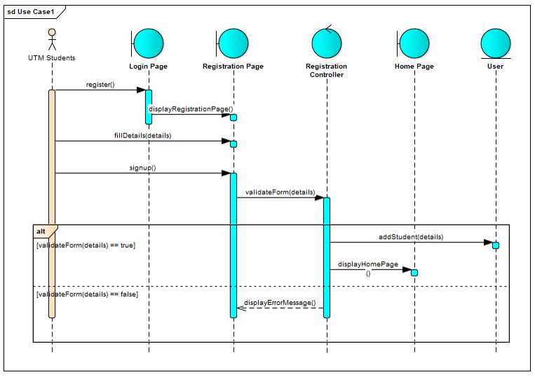
Figure 2.5: Sequence Diagram for <Name of User Story/Scenario if more than one scenario>
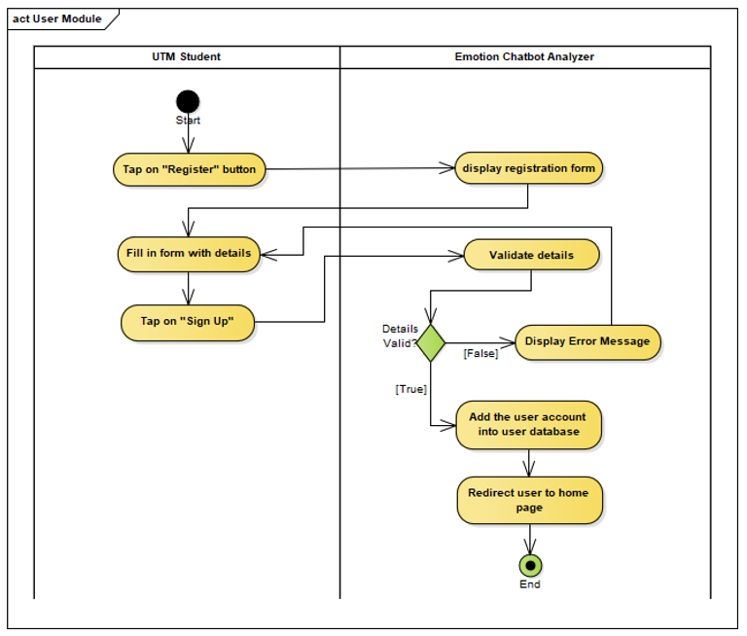
Figure 2.2: Activity Diagram for <<Name of User Story>>

    - US002: User Story <User Story 2>

    - US003: User Story <User Story 3>

    - USxxn User Story <User Story n>
…

  - Performance and Other Requirements
Non-functional requirements are the requirements that describe how the system should behave or operate, rather than what it should do. They address the characteristics or qualities of the system, such as its usability, reliability, performance, security, maintainability, and compatibility. Non-functional requirements are important to write in the SD because they help ensure that the system meets the stakeholders' needs and expectations.The ISO/IEC/IEEE 29148 standard suggests that non-functional requirements should be specified under three main categories: Software System Attributes, Performance and Other Requirements.

Example of Performance is as follows:
Performance requirements define the system's capability to respond to user requests and handle data in a timely manner. These requirements include the following:
- Response Time: The time it takes for the system to respond to a user request.
- Throughput: The number of requests the system can handle in a given period of time.
- Capacity: The maximum number of users or amount of data that the system can handle.
- Availability: The percentage of time the system is operational and accessible to users.

Example of Software System Atrributes are as follows:
Software system attributes define the overall qualities or characteristics of the software. These attributes are the foundation on which the software is built, and they include the following:
- Usability: The ease with which users can interact with the system.
- Reliability: The ability of the system to perform its functions correctly and consistently.
- Maintainability: The ease with which the system can be modified, repaired, and enhanced.
- Portability: The ability of the system to run on different hardware and software platforms.
- Compatibility: The ability of the system to work with other systems and components.
- Security: The protection of the system and its data from unauthorized access and malicious attacks.
- Safety: The ability of the system to operate safely without causing harm to users or the environment.
- Legal and Regulatory: Compliance with laws, regulations, and standards.
- Environmental: The impact of the system on the environment.

  - Design Constraints
Explain any constraints imposed by the organization where the software product will be used such as the system must adhere to certain organizational standard and other external non-functional requirements.

Example is as follows:
Environmental constraints: These constraints relate to the physical environment in which the system will operate, such as temperature, humidity, and lighting conditions. An example of an environmental constraint is: "The system must be designed to operate in temperatures ranging from 0°C to 40°C."

Hardware constraints: These constraints relate to the specific hardware components that will be used in the system, such as processors, memory, and storage. An example of a hardware constraint is: "The system must be designed to run on a minimum of 8GB of RAM."

Security constraints: These constraints relate to the security requirements for the system, such as data encryption, authentication, and access control. An example of a security constraint is: "The system must be designed to encrypt all sensitive user data using AES-256 encryption."

Compatibility constraints: These constraints relate to the compatibility requirements for the system, such as compatibility with specific software or hardware components. An example of a compatibility constraint is: "The system must be designed to be compatible with Windows 10 operating system."

Performance constraints: These constraints relate to the performance requirements for the system, such as response time, throughput, and capacity. An example of a performance constraint is: "The system must be designed to support a maximum of 1000 concurrent users with a response time of less than 5 seconds."

